***NAME : Himanshu Dixit***

***ENROLL NO. : B64178***

***BATCH : B10***

***SOFTWARE DEVELOPMENT FUNDAMENTAL LAB-I(15B17CI171) Assignment Sheet (WEEK-5 PHASE-2)***

***Lab A***

**1.** Write a C program to find the average of n numbers using arrays.

**Solution:**

#include<stdio.h>

int main()

{

int size,a[100];

float sum=0,avg;

printf("enter the size :");

scanf("%d",&size);

printf("enter the number :");

for(int i=0; i<size; i++)

{

scanf("%d",&a[i]);

}

for(int i=0; i<size; i++)

{

sum=sum+a[i];

}

avg=sum/size;

printf("%f",avg);

return 0;

}

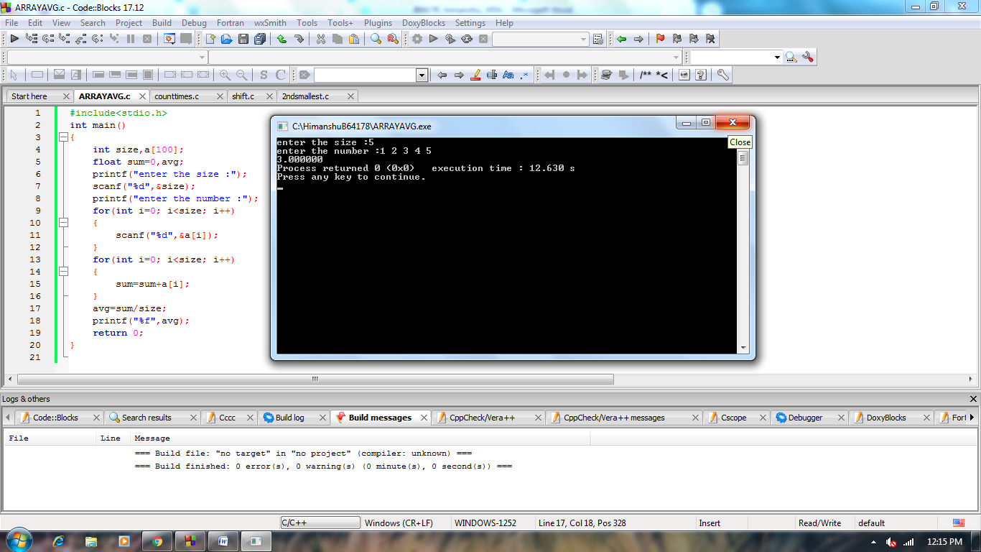

**2.** Write a C program to find the frequency of each element in an array.

**Example:**

**Input:** array = {1, 2, 3, 5, 2, 9, 7, 3, 5}

**Output:**

1 occurs 1 times

2 occurs 2 times

3 occurs 2 times

5 occurs 2 times

7 occurs 1 times

9 occurs 1 times

**Solution:**

#include<stdio.h>

int main()

{

int a[100],size,count=0,max=0;

printf("enter the size :");

scanf("%d",&size);

for(int i=0; i<size ;i++)

{

scanf("%d",&a[i]);

}

for(int i=0; i<size ;i++)

{

if(max<a[i])

max=a[i];

}

//printf("%d",max);

for(int i=1; i<=max; i++)

{

count=0;

for(int j=0; j<size; j++)

{

if(i==a[j])

count++;

}

if(count!=0)

printf("%d occures %d times\n",i,count);

}

return 0;

}

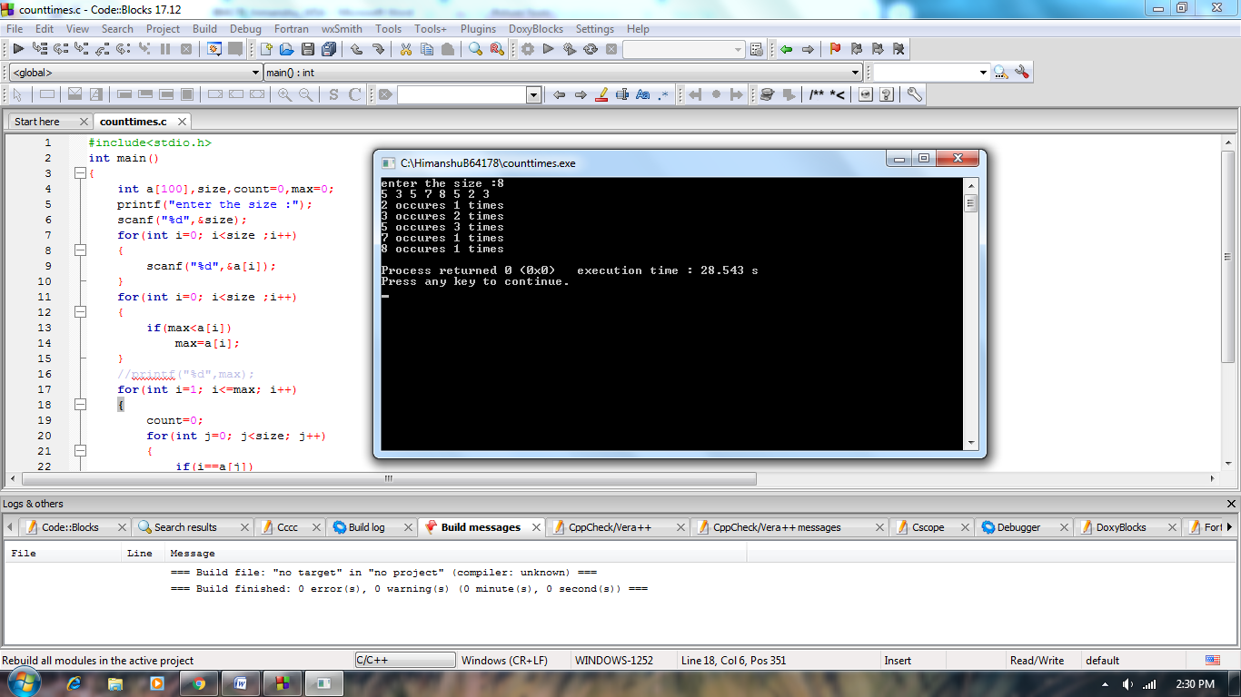

**3.** Given an array, write a program to left rotate the elements of the array by one.

Example:

Array Elements before rotating: 1 2 3 4 5 6 7

Array Elements after rotating: 2 3 4 5 6 7 1

**Solution:**

#include<stdio.h>

int main()

{

int size,a[100],b[100];

scanf("%d",&size);

for(int i=0; i<size; i++)

scanf("%d",&a[i]);

b[size-1]=a[0];

for(int i=1; i<size; i++)

{

b[i-1]=a[i];

}

for(int i=0; i<size ;i++)

printf("%d ",b[i]);

return 0;

}

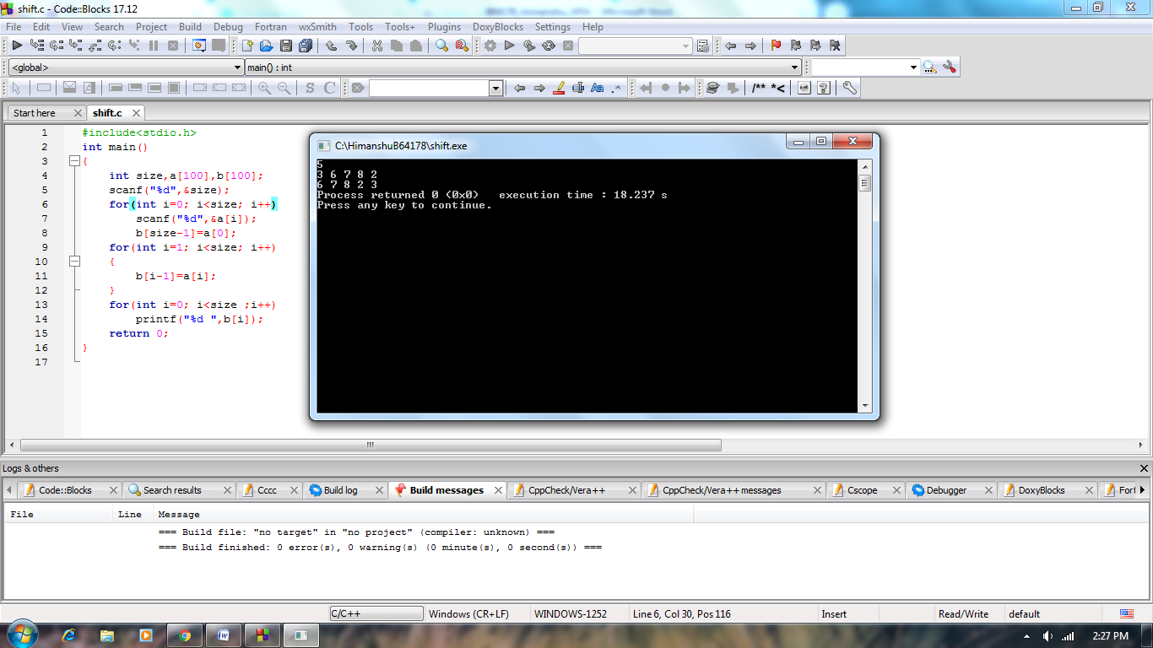

**4.** Write a C program to find the second smallest element in a one dimensional array.

Example: Input: Array size: 4

Elements: 32    54    -6   -15

Output:     -6

**Solution:**

#include<stdio.h>

int main()

{

int size,a[100],min=a[0],k;

scanf("%d",&size);

for(int i=0; i<size; i++)

scanf("%d",&a[i]);

for(int i=0;i<size;i++)

{

for(int j=i+1;j<size;j++)

if(a[i]>a[j])

{

k=a[i];

a[i]=a[j];

a[j]=k;

}

}

printf("%d",a[1]);

return 0;

}

